Contents

Non-Player Characters 1

Lif 1

Appeasing Lif 1

Destroying Lif 1

Talisolvanar "Tally" Fellbranch 1

Connections 1

Embric 2

Avi 2

Fala Lefaliir 3

Rishaal the Page Turner 3

Vincent Trench 3

Remallia Haventree 4

Quest 4

Skeemo Weirdbottle 4

Meloon Wardragon 5

Vajra Safahr 5

Mattrim "Threestrings" Mereg 7

Opening 7

Talking up Killigan 7

College stories 7

Catching up 7

Closing 7

Yagra Stonefist 8

Opening 8

Catching Up 8

Stories from on the run 8

Closing 8

Jalester Silvermane 9

Lords' Alliance Contact 10

References 10

Connection to Riley 12

Connection to Naivara 13

Obaya Uday 15

Early life 15

References 15

Emmek Frewn 17

Goals 17

Assets 17

Emmek’s Plan 18

The Shard Shunners 19

# Non-Player Characters

## Lif

The former tavern Trollskull Manor is haunted by the poltergeist ([specter](https://www.dndbeyond.com/monsters/specter)) of the tavern's previous barkeeper, a half-elf named Lif. Maintaining the tavern was his life's work and he couldn't abandon the place in death.

Lif invisibly causes mischief at the expense of the new owners by smashing plates, breaking beer barrels, and so forth. If the characters don't take the hint, it writes not-so-subtle warnings (such as "Closing time!" and "Last call!") on dusty floors and grimy windows. To truly claim the tavern as their own, the characters must either appease the poltergeist or destroy it.

Lif understands Common and Elvish, but it can't speak.

### Appeasing Lif

If the characters work to repair and renovate the tavern with the goal of opening it to the public again, the poltergeist may begin to accept them as the new owners and gradually becomes quite accommodating: pulling out a chair when a character wants to sit down, pouring a beer and delivering it to a character, taking coats when folks come in from the rain, and so forth. Once the business is up and running, Lif can also perform other helpful functions, such as locking doors, sweeping floors, and so forth.

### Destroying Lif

However, if the player characters become deeply invested in spending time with Trollskull Manor consider starting *The Haunting at Trollskull Manor* a short sub-adventure. In which Lif takes on a more sinister vibe and likely will have to be destroyed during *Act I: New Blood*.

Lif's poltergeist is destroyed if its hit points are reduced to 0. If attacked, it flees to the uppermost level of the turret when reduced to half its hit points. From there it fights to the bitter end.

## Talisolvanar "Tally" Fellbranch

The owner and chief artisan of the Bent Nail a woodshop in Trollskull Alley is a male half-elf carpenter and woodcarver.

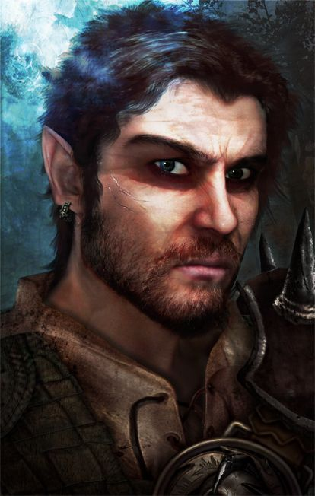

*A middle-aged half-elf sits on a stool whittling away at a wooden cane. It takes a few seconds before he looks up from his work to acknowledge your presence.*

*The lines on his face are accentuated by his furrowed brow and squinting eyes as his eyes adjust from is close whittling to you at the door. After a second the lines nearly disappear into a scruffy beard and his pointed ears relax into his short dark hair as his face relaxes.*

*“Welcome. Feel free to take a look around. Everything is handcrafted in house. We do most of our work in bulk contract. However, the pieces here are examples of our finer more custom work. Let me know if you have any questions.”*

*He returns to his whittling.*

He is a [commoner](https://www.dndbeyond.com/monsters/commoner), with these changes:

• Tally is chaotic good.

• He has these racial traits:

He has advantage on saving throws against being charmed, and magic can't put him to sleep.

He has darkvision out to a range of 60 feet. He speaks Common and Elvish.

### Connections

Steel and Wood

## Embric

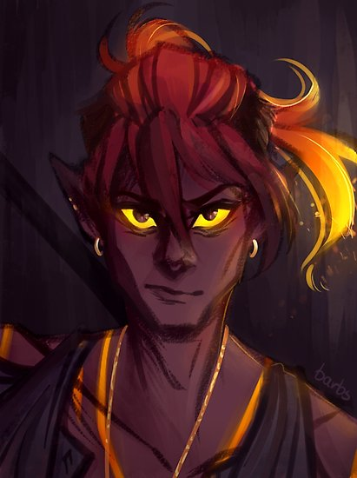

Embric tends the forge and is an expert weaponsmith. He claims descent from the efreet of Calimshan and is prone to extreme mood swings.

He is a member of the Most Careful Order of Skilled Smiths and Metalforgers in Waterdeep.

He has the statistics of a [bandit captain](https://www.dndbeyond.com/monsters/bandit-captain), with these changes:

* Embric is neutral good.
* He has these racial traits: He can cast [*produce flame*](https://www.dndbeyond.com/spells/produce-flame)at will. (Constitution is his spellcasting ability, and he has a +4 bonus to hit with spell attacks.) He has darkvision out to a range of 60 feet and resistance to fire damage. He speaks Common and Primordial.

## Avi

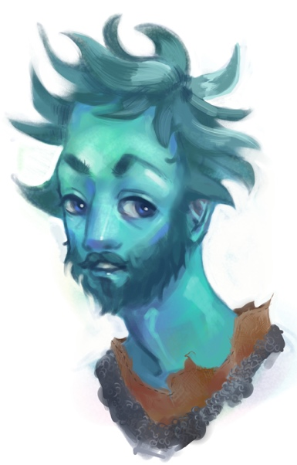

Avi worships Eldath, god of peace, and uses his magic to quench hot steel. He is also an expert armorsmith.

Avi is laid back and speaks plainly.

He is a member of the Most Careful Order of Skilled Smiths and Metalforgers and the Splendid Order of Armorers, Locksmiths, and Finesmiths in Waterdeep.

He has the statistics of a [priest](https://www.dndbeyond.com/monsters/priest), with these changes:

* Avi is neutral good.
* He has these racial traits: At will, he can control the flow and shape of water in a 5-foot cube, or cause the water to freeze for up to 1 hour.
* He has a swimming speed of 30 feet, and he can breathe air and water.
* He has resistance to acid damage. He speaks Common and Primordial.

## Fala Lefaliir

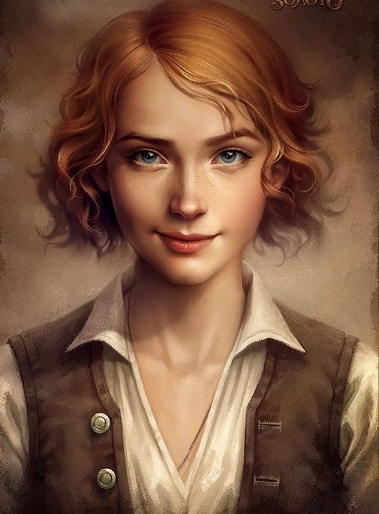Fala is an herbalist and a member of the Guild of Apothecaries and Physicians, operates her shop, Corellon’s Crown, out of a stately, three-story town house, in Trollskull Alley in Waterdeep’s North Ward.

Fala is an outgoing wood elf with red curly hair. Like the elven god Corellon Larethian, Fala is neither male nor female. If referred to as "he" or "she," Fala gently requests to be addressed by name or as "they."

Fala is “friends” with a member of the Zhentarim named Ziraj, who saved Fala's life. He visits Fala from time to time, and Fala has set aside a room for him on the second floor.

Fala is a [druid](https://www.dndbeyond.com/monsters/druid), with these changes:

Fala is chaotic good.

Fala has these racial traits:

Fala has advantage on saving throws against being charmed, and magic can't put Fala to sleep. Fala has a walking speed of 35 feet and darkvision out to a range of 60 feet. Fala speaks Common, Druidic, and Elvish.

## Rishaal the Page Turner

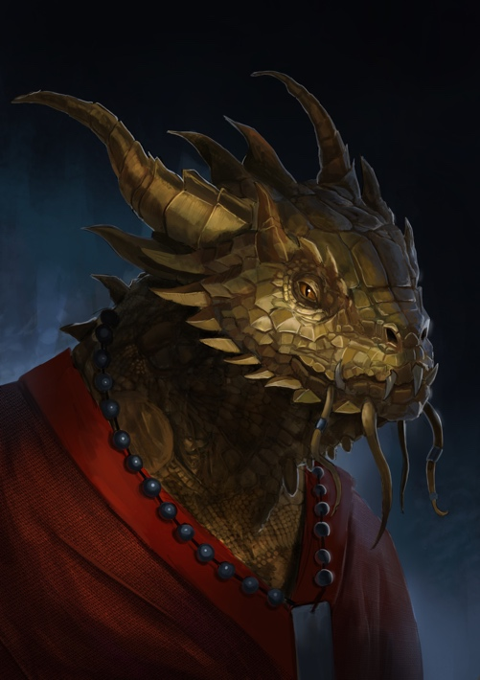Rishaal the Page-Turner is a short dragonborn of gold dragon ancestry.

A member of the Watchful Order of Magists and Protectors, Rishaal is a [mage](https://www.dndbeyond.com/monsters/mage), with these changes:

He has these racial traits:

He can use his action to exhale a 15-foot cone of fire (but can't do this again until he finishes a short or long rest); each creature in the cone must make a DC 10 Dexterity saving throw, taking 2d6 fire damage on a failed save, or half as much damage on a successful one.

He has resistance to fire damage.

He speaks Common, Draconic, Dwarvish, and Elvish.

## Vincent Trench

*Leaning against the desk is a human man dresses in a sharp suit and smoking a slim pipe.*

*“Vincent Trench, private investigator. What can I do for you?”*

Vincent is in fact a rakshasa named Valantajar that always casts disguise self on itself before seeing visitors. The rakshasa has lived in Waterdeep for years switching identities as often as needed to keep its true nature hidden. It has grown accustomed to living among mortals and, much to its own astonishment, is rather fond of Waterdeep and its citizens.

## Remallia Haventree

Remallia (Remi to her friends) is the lady of House Ulbrinter and a guiding light for the Harpers in Waterdeep. She became an active force for good in the city after assassins killed her husband Arthagast Ulbrinter and destroyed his remains. A sun elf, she has two adult children (a half-elf son named Arthius, who is studying music in Silverymoon, and a half-elf daughter named Serenore, who lives on the Moonshae island of Alaron with her husband and daughter). Lady Haventree retains a handful of loyal servants and spies.

Remi holds secret Harper meetings in her villa, which is warded by all manner of spells. She uses a silver raven figurine of wondrous power to deliver messages to Harper spies scattered throughout the city.

## Quest

Quest is a close friend of Remallia Haventree and works as the Lady’s personal attendant. Wherever Remi is Quest is close by.

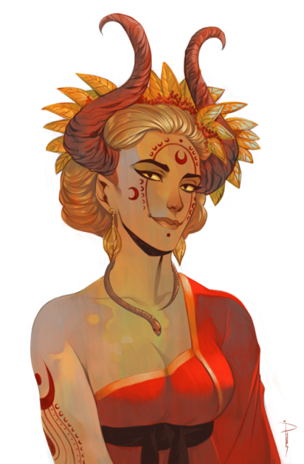

“*You are met by a tall, well-dressed tiefling. With purposeful yet graceful steps she crosses the large entry room to greet you.*

*As she does she holds a pleasantly professional smile below vaguely catlike eyes. Her long blond hair is up in a loose bun behind long curved reddish amber horns and pointed elfish ears.”*

## Skeemo Weirdbottle

Skeemo became the Master of Magic for the Black Network in Waterdeep, setting up a cover in the Trades Ward in the form of a cramped little shop called Weirdbottle's Concoctions.

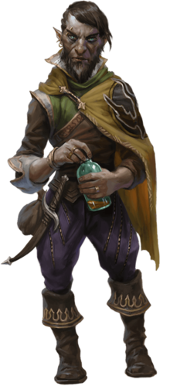

Most of his potions and elixirs are non-magical, but he crafts magical ones for his Zhent friends.

Skeemo can add 'sellout'’ to his credentials, his services having been bought by House Gralhund and the Black Network operatives loyal to Manshoon. The rock gnome uses paper birds (see appendix A) to send messages both to his new friends and his old ones.

## Meloon Wardragon

Meloon is a handsome, formidable warrior in his prime who serves the goddess Tymora and loves a good fight. His friends- among them Renaer Neverember and Vajra Safahr- describe him as honest, optimistic and extraordinarily lucky.

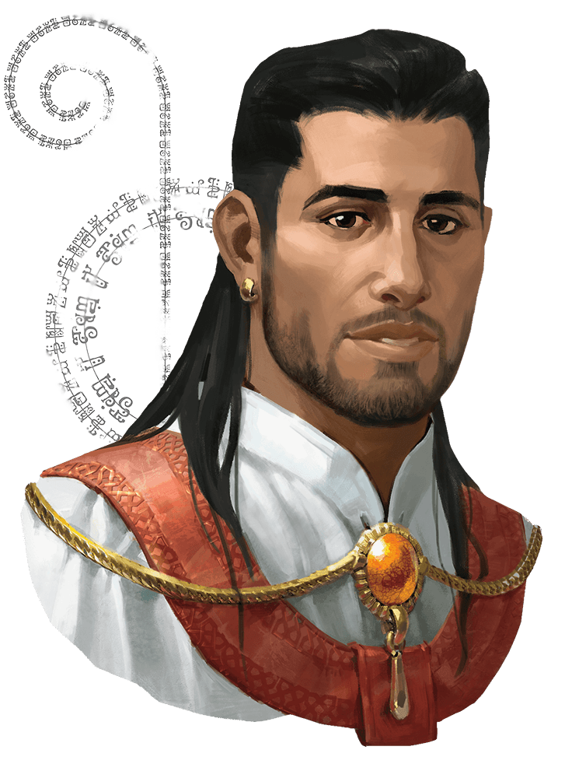

Until recently this description of Meloon as a member of Force Grey and reporting directly to the Blackstaff was accurate.

However, three months ago, out of boredom. Meloon accompanied a fledgling band of adventurers on an expedition to Undermountain. There, his luck ran out. While resting in the dungeon, the adventuring party was attacked by monsters unleashed by Xanathar- including a number of intellect devourers. One of the creatures succeeded in magically devouring and replacing Meloon's brain, turning the champion of Tymora into a puppet. After finishing off his unsuspecting companions, Meloon returned to Waterdeep as a Xanathar Guild spy.

The intellect devourer that inhabits Meloon's skull was bred by Nihiloor, a mind flayer in Xanathar's employ. It knows everything Meloon knew, and Meloon behaves much as he did before his descent into Undermountain. He hangs out at the Yawning Portal, tries to bond with adventurers, and offers a helping hand whenever doing so feels appropriate. The intellect devourer's primary goals are to steer adventurers away from Undermountain and get them to undertake quests that further the aims of Xanathar. Such quests usually involve the eradication of Xanathar's enemies, and Meloon is all too eager to fight alongside those who fall for his ruse.

In recent months, Meloon has spent much of his time at the Yawning Portal.

## Vajra Safahr

Young and vibrant, diminutive, with olive skin, short black hair, and indigo blue eyes. Vajra is a capable wizard in her mid-thirties, the youngest person ever to hold the position of Blackstaff. As the

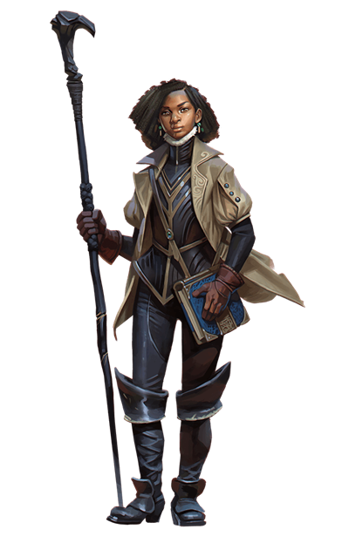High Wizard of Waterdeep, she is charged with using all the magic and resources at her disposal to defend the city against threats. She was handpicked for the job by Khelben Arunsun, and wields the **Blackstaff**fromwhich Khelben derived his name and the title of the office.

Vajra isn't the city's most powerful wizard, but she can hold her own. Despite her many gifts, she still questions her ability to meet the demands of her role, and she rarely makes a decision without first soliciting the advice of the *Blackstaff,* which contains Khelben Arunsun's spirit as well as the spirits of all the other Blackstaffs who preceded her. She also gets intelligence from many other sources, both through her own network of spies and from Harper agents.

Vajra runs Blackstaff Academy, a school for mages, out of Blackstaff Tower in the Castle Ward. She is also in charge of Force Grey, an order of highly skilled adventurers who are called upon to defend the city in times of need. Vajra is always looking for new adventurers to fill the ranks of Force Grey, and she is particularly interested in those who can bring unique skills, abilities, or spells to the mix.

Several of the older and more seasoned wizards in Waterdeep consider Vajra an upstart, but they are smart enough not to challenge her. Only the Open Lord, currently Laeral Silverhand can strip Vajra of her title.

## Mattrim "Threestrings" Mereg

### Opening

At the end of the bar you see Threestrings caually conversing with one of the barmaids while he tunes up his lute. Over the din of the room you can't hear what is being discussed however they appear to be having a friendly chat.

Do you approach?

### Talking up Killigan

Threestrings introduces Killigan to "Bonnie", a friend whom he has been helping settle into the city since she arrived about a year ago.

Threestrings talks up Killigan to Bonnie as they reminisce about their college days.

"Your axe is killer!"

"This guy wrote "Travelling Bard"

### College stories

* They attended [New Olamn](https://forgottenrealms.fandom.com/wiki/New_Olamn). Killigan commuted from Amn via portal, Mattrim lived on campus.
* They were a duo performing around campus under the name "[Wyld Stallyns](https://www.youtube.com/watch?v=7mi4h00fedY)”.
* Mattrim got the name "Threestrings" junior year. During finals someone stole Mattrim's lute minutes before his final for advanced Lute. With such little time he had to grab an old artifact lute off the wall of the performance hall as he walked in. It only had three strings and he had to perform "The Three Flambinis" had to find a new one last minute. The only lute he could find on short notice was an old relic displayed on the wall of the schools concert hall lobby.
* Wyld Stallyns broke up when Mattrim learned Killigan had hidden his lute but it was a long time coming already. Killigan was already going all Paul and Mattrim all John. But just before graduation they reconciled and reunited for a few “[Wyld Stallyns](https://www.youtube.com/watch?v=7mi4h00fedY)" shows leading up to graduation.

### Catching up

"What was the last time we saw each other?"

Threestrings tells Killigan that he lives out of a room at the Yawning Portal and spends most nights strumming a few tunes around the tap room and chatting up adventurers. Threestrings seems happy and comfortable.

### Closing

**If Threestrings is asked about Floon,** read the following:

Eventually from behind the bar you hear Durnan yell.

"Alright! Get her up! Get her to the bathroom!"

At the far end of the portal, you see a few patrons try to help Yagra Stonefist back to her feet but the half-orc mercenary just pushes them back and tands on her own.

"Yagra!" Durnan yells again. She turns to scowl at him from across the room. He continues "You're bleedin' on my floor. Hit the bathroom and clean yourself up girl!"

Yagra complies and pushes her way to the bathroom, kicks the door open and disappears in. As the door swings back the form of a skinny guy which his pants around his ankles pushes out.

As you both turn to continue your conversation you realize that Bonnie has left, moving on to her work duties.

Somewhat abruptly Threestrings puts away his lute and turns much more serious.

"Killigan... A word of warning. Waterdeep has gotten dangerous lately. I'm not sure what caused it but bad blood between the Zhentarim and Xanathar Guild has begun to spill into the streets. It's likely that our little brawl earlier was an example of it.

"It's good of you to help out old Volo... but be careful. If Floon went missing in the Dock Ward, there's a good chance that is related to this turf war as well."

## Yagra Stonefist

Yagra is a Black Network mercenary who gets paid to protect a Zhent negotiator named Davil Starsong. Yagra finds the job boring and likes to pass the time by challenging adventurers to arm wrestle. (Resolve such contests using contested Strength checks.)

If the characters express their opposition to the Xanathar Guild, Yagra might urge them to speak to Davil about joining forces with the Zhentarim to destroy the beholder crime lord.

Yagra is a half-ore thug. When reduced to 0 hit points, she drops to 1 bit point instead (but can't do this again until she finishes a long rest). She has darkvision out to a range of 60 feet. She speaks Common and Orc.

### Opening

After being knocked cold during her brawl with Xanathar Guild members then coming to a few minutes later. Yagra, at Durnan's insistence, begrudgingly went into the bathroom to "clean up". She emerges now, the bleeding has stopped and she has a couple new bandages on her face.

Do you approach?

### Catching Up

Yagra encountered Nala as she fled from the Druidic clan that raised her but would not let her leave them.

Yagra fought off and killed some of the druids that persued Nala as she fled. After that the two spent some time together surviving in the wilderness. They became friends until one day Nala woke to find Yagra gone.

Yagra is vague about her reasons for leaving. She just says "You didn't need my protection any more." A DC12 Insight check reveals that there is probably more to the story but Yagra is tightlipped about it and unwilling to say more.

**If asked what she does now.**

I protect a Zhent negotiator named Davil Starsong. It's boring but it pays the bills.

Other than that I drink and arm wrestle.

**If asked details about the Zhentarim and Xanathar Guild**

She shrugs and in a familarly detached and shortlipped way Yagra sums things up from her perspective.

"The Zhent's pay well but other than that I dunno."

**If asked about Floon**

"People like Volo and Floon should not be at The Skewered Dragon. They're too soft and have no sense. The Dock Ward is not safe for them."

"Davil might know something but I can't be sure. If you want to talk to him tomorrow let me know. I can introduce you."

* TODO: Why did Yagra leave Nala?
* TODO: How did Yagra come to be employeed by the Zhentarim as Davil's bodyguard?

### Stories from on the run

1. Yagra and Nala hunt
2. Yagra and Nala help a farmer

### Closing

"Listen, good luck finding that fool Floon. If you're looking for some real work while you're here. I can probably set you up with some."

Yagra looks past you and nods to someone. She puts a firm hand on your shoulder and begins making her past you. As she does so she finishes. "Like I said The Zhents can be counted on to pay well."

She then sits down at a table behind you and sets up to arm wrestle an equally imposing dwarf.

## Jalester Silvermane

"Want to know what's going on in our fine city? Grab a stool. Stay a while."

An earnest man in his mid-twenties, Jalester hails from the distant land of Cormyr, where he earned his spurs working for a mercenary company called the Steel Shadows. A few years ago, Jalester left the Dales and traveled to Waterdeep with several other members of the company, one of whom -Faerrel Dunbladewould become his best friend and lover.

The wizard Elminster befriended the two young men and brought them to the attention of Laeral Silverhand, who put them to work as deputies and spies. Last year, Jalester and Faerrel helped the Open Lord expose a plot to overthrow the government, but Faerrel was killed in a street fight while helping bring the perpetrators to justice. Jalester remained in Waterdeep afterward and became one of Laeral's field operatives in the service of Waterdeep and the Lords' Alliance.

Laeral has asked him to keep an eye on adventurers who might, through their actions, aid or imperil the city and its citizens. Since the Yawning Portal attracts adventurers of all sorts, Jalester spends a lot of time there, usually seated by himself in a quiet corner. Durnan knows that Jalester works for Laeral and leaves the young man alone.

He has been romantically unattached ever since Faerrel's death but is often distracted by thoughts of his deceased boyfriend. When not engaged in alliance business. Jalester is lonely and looking for love.

Jalester carries a badge of the Watch. If the badge is lost or taken from him, it returns to Laeral Silverhand.

### Lords' Alliance Contact

Jalester is the characters' primary contact with the Lords' Alliance. He offers membership to those who qualify. Members are expected to complete whatever missions are assigned to them in a timely, professional manner. Refusing to accept or complete a mission can result in suspension or dismissal.

An alliance member who is suspended receives no alliance missions until the suspension ends, while dismissal from the alliance means a loss of membership and the loss of all renown in the faction.

#### Benefits

A member of the Lords' Alliance on good terms with Jalester Silvermane can use that connection to attempt to **secure a griffon mount** *(see page 48 of Waterdeep: Dragon Heist for details)*.

They can **request an audience with Laeral** through Jalester. Laeral gives them a gift -a feather quill given to her by the archmage Elminster himself if they promise to return the stolen gold to Waterdeep's coffers. *(see page 91 of Waterdeep: Dragon Heist for details)*

If the characters joined the Lords' Alliance and kept Jalester informed of their progress, **reinforcements can arrive during the final battle in The Vault** to help combat the villains or introduce a new element to the situation. *(see page 98 of Waterdeep: Dragon Heist for details)*

Characters who are members of the Lords' Alliance can reach out to Jalester Silvermane to **find Xanathar's secret lair**. Jalester doesn't know the location of Xanatbar's lair but can get the details from Laeral Silverhand. With the information in hand, Jalester leads the party to a secret entrance. If one or more characters have renown of 4 or higher in the Lords' Alliance, **Jalester offers to join the party on its mission into Xanathar's lair.** *(see page 101 of Waterdeep: Dragon Heist for details)*

### References

#### Cormyr

* [Cormyr Wiki](https://forgottenrealms.fandom.com/wiki/Cormyr)
* [Cormyr Map](https://vignette.wikia.nocookie.net/forgottenrealms/images/9/95/Cormyr_-_1479_DR_copy.jpg/revision/latest?cb=20081014082233)

#### Suzail

* Refer to "Backdrop: Suzail" *(pages 63-75 of Dungeon Magazine 198)*
* [Suzail Wiki](https://forgottenrealms.fandom.com/wiki/Suzail)
* [Suzail Map](http://www.wizards.com/dnd/files/suzail_high.jpg)

### Connection to Riley

Grew up in and around Suzail, the capital of Cormyr. He lived across the street from Riley.

When was the last time Jalester and Riley saw each other? How old were they?

Jalester remembers overhearing a conversation Riley's father had before he left for war.

In fact her father did not go off to the war at all. He instead joined on with a merchant ship that set sail for the Sea of Fallen Stars

#### Riley backstory

Riley was born in Suzail, the capital of Cormyr, to a wealthy noble family. However her mother died giving birth to her. She was raised by her father until the age of 5, when undead attacked the city.

This forced Suzail and the surrounding area into war against a powerful evil necromancer, a war that took her father to battle hundreds of miles to the north. Riley was left alone to be raised with the clergy at their local cathedral (The Silent Room, a temple to the god of knowledge, Oghma).

The war dragged on for the next ten years however the people of Suzail finally did prevail. Many soldiers returned home however her father was not one of them. Rumor has it that he was killed in battle. There is also another rumor that he was captured and held as prisoner. Riley never saw her father again and does not know what became of him.

She has spent her life studying the magical school of Necromancy in order to become more powerful and help prevent such brutality from happening again in her city. Perhaps by gaining knowledge of the undead arts that led to the war she could better understand why her father was taken from her and never return.

Riley would like to know from The Oracle what had become of her father. Is it true that he may still be alive being held as a prisoner, waiting for rescue?

In pursuing The Oracle, Riley died and was revived but lost her arm in the process. It was replaced with a magically powered prosthetic called the Spinning Arm of Erathis.

The Oracle answered Riley's question like this:

“To the east I see a sky of stars falling to the sea. In their fading light, a ship’s crew toils mindlessly into eternity. A prison with no bars. He weeps for you now, as he was once so near as to reach out and touch you, to hold you again. You are separated by but a heartbeat. But Beware, judgement often awaits those who seek the lost. I see a wall of weeping on your path and a trail of blood in your wake.”

Riley suddenly remembered a time when she was sitting on the dock of a bay with her father, this memory was remembered thanks to Killigan and his bard of inspiration spell. It made Riley tear up.

### Connection to Naivara

A few years ago, when the masked Lords of Waterdeep learned that the then Open Lord, Dagult Neverember had embezzled half a million dragons they voted him out of office and Laeral Silverhand took on the job. Dagult was off rebuilding the city of Neverwinter at the time and when news of his ousting made it to him he went into hiding there.

Jalester and his boyfriend Faerrel were a part of a group tasked by Laeral with traveling to Neverwinter to gather information about the whereabouts of Dagult Neverember and ultimately bring him back to Waterdeep. It was then that Jalester came into contact with Naivara. While the mission failed to locate the disgraced Neverember, Naivara did provide Jalester with useful intel at that time.

The relationship between Jalester and Naivara seems cordial but uneasy. It could be that Jalester was put off by her methods.

What was the specific nature of the contact between Jalester and Naivara?

#### Opening

Off in a quiet corner of the tavern you see Jalester sitting alone.

Do you approach?…

"Naivara. What brings you this far south?

#### Catching Up

"What news do you have from Neverwinter? Any word on the whereabouts of old Dagult? I would very much like to recover that weasel. If not for the city's closure, then for my own."

"Or perhaps that floating island that was spotted in the sky to the north a few weeks ago?"

In return for some form of valuable new info Jalester reveals that he has learned some info about the Xanathar's Guild.

"Rumors have begun circulating among Xanathar Guild members that The Xanathar has taken on a new advisor lately. A drow woman cloaked in Yellow."

**If asked about the whereabouts of Floon**

"Yes, well I'll have to admit that I'm not quite up to speed on the drama surrounding lives of the city's more frivilous citizens like Floon. So I can't personally help you there.

You say he was taken by the Xanathar's Guild?"

A look of disgust crosses Jalester's face and he looks through a nearby window to the street.

"That would likely mean he has been taken underground. If he went missing in the Dock Ward, the Xanathar's Guild is known to access the sewers at a few locations."

Jalester describes a particular alleyway near the warehouse where you found Renaer that would probably be the best place to start.

#### Closing

"Well Naivara, I must be going. No rest for the wicked..."

*Jalester sighs with a wry smile.*

"That's a joke. You see I work for the Lord's Alliance and you're a Drow. Anyway..."

"Take care looking for Floon. If he is wrapped up in this gang war, finding him will be dangerous work.”

## Obaya Uday

Obaya, a priest has traveled from Chult to sponsor expeditions into Undermountain, with the goal of bringing its magical treasures back to her employer, the merchant prince Wakanga O'tamu of Port Nyanzaru. She discourages low-level adventurers from exploring Undermountain but is happy to help them with her magic until they gain enough experience to be useful to her.

If you plan to run Waterdeep: Dungeon of the Mad Mage after this adventure, Obaya can take on a more prominent role as an advisor and a source of quests.

### Early life

For a time she was the leader and object of worship of a strange cult in Amn that for a time had Maynard in it's thrall. Upon meeting again at the Yawning Portal she acted as though she did not know him.

### References

[Waukeen Wiki](https://forgottenrealms.fandom.com/wiki/Waukeen)

[Chult Wiki](https://forgottenrealms.fandom.com/wiki/Chult)

## Emmek Frewn

Emmek Frewn, a salty northerner (NE male Illuskan commoner), recently tried to buy the tavern in Trollskull Alley but was outbid by Volothamp Geddarm. Stung by the loss, he bought a smaller, less impressive building in the same alley and turned it into a pub, which he calls Frewn's Brews.

Emmek's family migrated to Waterdeep after its holdings in Neverwinter were destroyed by the eruption of Mount Hotenow in 1451 DR. The family struggled to make ends meet by tanning leather in the Trades Ward. After Emmek's parents died, his sisters took over the business and bought him out. He never liked the work anyway, and he particularly hated dealing with the League of Skinners and Tanners.

Emmek is on shaky financial footing because he has sunk most of his wealth into this latest endeavor. He's also in trouble with two of the guilds. First, he tried to save coin by fixing the roof himself. in defiance of the Carpenters', Roofers’ and Plasterers Guild. Then he offended a member of the Cellarers' and Plumbers' Guild by comparing the dwarf's beard to barnacles on a ship.

### Goals

Emmek wants his pub to be the most successful tavern in the North Ward, and he wants the characters' business to fail spectacularly.

### Assets

Emmek is stingy when it comes to certain kinds of expenses and foolish with his coin in other ways. He tends to spend a lot on big, showy items and cut corners on the little amenities. Because he doesn't have much coin to throw around right now, his plan to ruin the characters' establishment begins with borrowing some money.

Emmek secures a 150 gp loan from lstrid Hom (see appendix B). He spends 50 gp for the services of the Shard Shunners, a gang of halfling wererats with which he has had nefarious dealings in the past.

### Emmek’s Plan

Emmek's strategy for ruining the competition and the consequences for putting it into action are summarized in the table below.

|  |  |
| --- | --- |
| **Element** | **Description** |
| Event | The wererats scope out the characters' tavern in halfling forms and might try to get jobs there. |
| Event | The wererats plant morsels of food inside the characters' place and bore tiny holes in the outside walls to attract rats, creating an infestation. |
| Action | Emmek spreads rumors that the characters' tavern is rat-infested, which is why he didn't buy it. Apply a -10 penalty on the next three rolls characters make on the Running a Business table (see "Tavern Keeping Expenses," page 41). |
| Event | The Shard Shunners claim they've done enough for their coin and demand more. |
| Action | Emmek pays the were rats another 50 gp to creep around the characters' tavern at night in hybrid and rat form, carve rat faces into the doors of neighbors, and otherwise draw attention to themselves. |
| Action | Emmek convinces several local residents to sign a letter he has drafted, then dispatches it to the City Watch. The letter accuses the characters of running a front for a guild of wererat thieves and urges the Watch to close their establishment. |

## The Shard Shunners

a gang of halfling wererats with which he has had nefarious dealings in the past. He pays the halflings to hinder the characters' efforts while he works feverishly to manage his own business.

Four gang members have been assigned to work with Emmek: two males named Kelso Fiddlewick and Dasher Snobeedle and two females named Danika Fiddlewick (Kelso's younger sister) and Brynn Hilltopple. These halflings are wererats, with these changes:

* Each wererat is Small and has 27 (6d6 + 6) hit points.
* It can move through the space of a Medium or larger creature.
* lt has advantage on saving throws against being frightened.
* It speaks Common and Halfling, and it knows thieves' cant.